The Wild West Notes
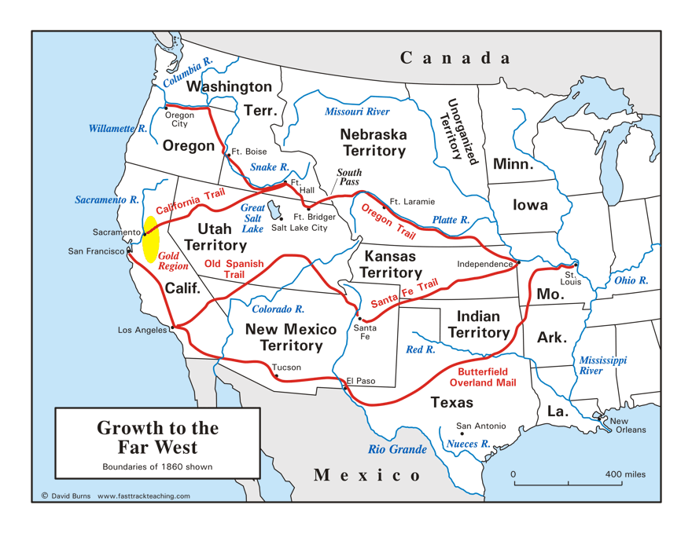
- Miners
- Three types of mining
  - Placer (_____________)
  - Quarts (_____________)
  - Hydraulic (spraying _____________)
- Precious _____________ being mined in the West:
  - Gold (49ers)
  - Silver
  - Copper
- ________ mining coal, salt, or diamonds
- The Comstock Lode
- Nevada __________
- So much silver that the _________ was shiny in the sunlight
- Underground ___________ held up by beams and supports
- Boomtowns
- Town that pops up almost __________________ due to a surge in activity
  - Mining
  - Homesteading
  - Logging
- No reputable _______________ (at first)
- Once the basics are there, then the ____________ come – newspapers, entertainment, etc.
- Had to use local __________________ until the __________________ gets set up
- Crime
- Certain towns become ________________ for _________________ activity
  - Deadwood
  - Tombstone
- _____________________________ become famous
  - Earp brothers
  - Jesse James
  - Doc Holliday
  - Billy the Kid
  - Butch Cassidy
- A lot of money is there for the __________________
- A lot of “__________________” with business partners
- Territory ________________________
- Colorado, Montana, and the Dakota Territory created due to _________________
- Colorado alone yielded over __________________ in silver (back then money)
- Railroads are built all the way into _______________ (2nd largest city West of the Mississippi River then)
- ____________ in Dakotas
- ____________ in Montana
- Railroads
- The building of railroads for miners leads to the migration of others
  - __________________
  - __________________
- ________________________ Railroad Completed in 1869
- _____________________ = American folklore
- The ___________________________ Environment
- Flat
- Low rain fall
- All grass, no forests
- Army __________________ of 1819 to explore the new territory – “almost wholly unfit for cultivation.”
- “____________________” move in
- Open Range
- Most of the _____________________ of the Great Plains are originally owned by the _________________ – equal to a national park or game preserve
- Mexican cowhands (Vaqueros) add _____________ to our vocabulary
  - Lasso
  - Stampede
  - Cattle branding
  - Mavericks
- Longhorns
- Descendants of _______________________ that was brought over centuries before
- _____________ in the largest area of longhorn cattle
  - University of Texas ________________
  - By ___________ they figure over _______________________ longhorns are being ranched in Texas
- Railroads and cattle
- Before ___________ was not practical as a __________ for the masses because of transportation costs – but other meats cannot be sent _______________ to larger cities
  - Civil War ______________
  - General population
  - Coast to coast
- The Long Drive
- Cattle could be sold for _______ times the price in the East (supply and demand)
- Take ___________________ cattle in ______ trip hundreds or thousands of miles by horseback across the open range
- Take _________ with multiple ______________
- Poor confederates, Hispanics, African Americans
- Very ___________________
- Wild West Mythos
- Dime novels – _______________ for cowboy stories
- Create stereotypical stories about the ________________________
- __________________ it – the good guy always wins
- Europeans become __________________ with cowboys and Indians –huge migration to the USA for _____________________
- Range Wars
- Land __________________
- Cattle disputes
- Barbed ____________
- European breeds of cattle brought in to compete against longhorns
  - Angus – _______________
  - Jersey – _______________
  - Holstein – ______________
- The age of the ranging cowboy comes to an end as they are hired on as “_________________________” or “Rodeo Boys” (RBs = Arby’s)
- Homestead Act
- 1862
- For _______ registration fee = up to ________ acres/ 1 square mile of land
- Must live there for at least ____________ to own the title – prevents ________________________________________
- Brochures and pamphlets are distributed across the country and _____________
- People would have to __________ for land
- Hardships of _________________ the Great Plains
- Lack of ___________ = no building materials
- Lack of ___________ = deep wells (300+ feet)
- Summer temps over ________ degrees
- Winter has ____________________
- _____________________ alley
- Drought, wind erosion, and overuse of land kills the soil (eventually leading to the _______________________)
- ______________ eat crops
- Land Grant _____________________
- Morrill Act created colleges to educate people on ________________________________________
- ____________________________ is the first land grant college ever (1855)
- Texas A & M (Agriculture and Mechanics) is the _________________ in the USA
- New Technologies
- __________ farming
- ______________ resistant strains
- Steel _______________
- Seed _______________
- Mechanical ____________________
- ____________________ machines
- John Deere
- Bonanza Farms
- Faster and easier _________________ lead to larger farms
- Up to ________________ acres (over 300 square miles)
- Run by delegation like a ______________________
- USA is the leading exporter of ______________ by 1880
- Frontier Closing
- 1900
- End of an __________
- The ___________________________ of a fresh start needs to be redefined
  - Rags to ____________
  - Anyone can be the ____________________

Native Populations
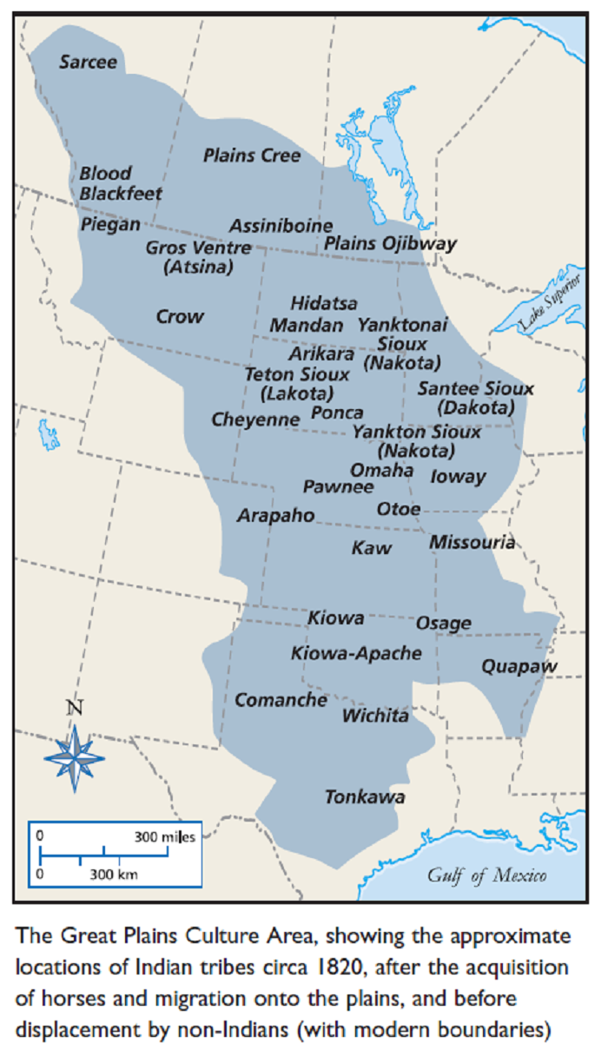
- _______________________________________ on the great plains
  - Dakota Sioux
  - Lakota Sioux
  - Cheyenne
  - Pawnee
  - Arapaho
  - Comanche
  - Crow
- Lifestyle
- Nomads
- Buffalo
- Natural World _______________
- Governing council of ____________
- Conflict
- ____________ settlements clash with native _______________
- Natives forced onto _______________________
- Whites ___________ natural resources
- Tribes become ________________ on the US government
- “Massacre” vs “battle” = _____________________________________
- 1862 Dakota ______________________
- No annuities came = ______________________
- “If they are hungry, let them eat grass or their own dung.”
  - said by ______________ Andrew Myrick
  - 2 weeks later he was found __________________ with ___________ stuffed into his ______________
- Hundreds _________ on both sides
- Worst mass __________________ in US History – (_____ natives _______________ at the same time)
- Fetterman’s Massacre
- 1866
- Wyoming
- Lakota
- US Government sends ____________ to “protect” __________________ coming through the Bozeman Trail
- __________ Crazy Horse, Red Cloud, and Sitting Bull wipe out _____________ soldiers in Wyoming by one _______________
- Sand Creek Massacre
- Cheyenne go to Fort Lyon to ________________________________
- General Chivington ordered to ____________ at first offer no matter what
- ______________ knows what really happened
- Cheyenne put on reservation and Chivington _________________________
- Little Big Horn
- June 25th, 1876
- Also known as “_______________________________”
- Lakota and Cheyenne led by _______________________________
- Miners moving in on reservation for _________ that was found
- Native ______________ enter ________________ territory (it is their hunting land after all)
- Custer attacks ___________ natives with ________ soldiers
- All US soldiers ___________
- Chief Joseph Surrender Speech
- October 5th, 1877
- “Tell General Howard I know his heart. What he told me before, I have it in my heart. I am tired of fighting. Our Chiefs are killed; Looking Glass is dead, Ta Hool Hool Shute is dead. The old men are all dead. It is the young men who say yes or no. He who led on the young men is dead. It is cold, and we have no blankets; the little children are freezing to death. My people, some of them, have run away to the hills, and have no blankets, no food. No one knows where they are - perhaps freezing to death. I want to have time to look for my children, and see how many of them I can find. Maybe I shall find them among the dead. Hear me, my Chiefs! I am tired; my heart is sick and sad. From where the sun now stands _________________________________________________.”
- Dawes Act
- 1887
- Natives given _____________________________, not just reservations
- No __________________ anymore
- _____________________ expected
- Wounded Knee
- 1890
- US _____________ sent to _______________ the Lakota tribe
- Revenge for Little Big Horn - ___________________ later
- ______ US Soldiers die
- ______ Lakota Men, Women, and Children die
- Indian Peace Commission
- 2 ______________________
  - One in the north
  - One in the south
- __________________________________ will run the reservations
- Only __________________________ allowed in – no ____________ police or authorities – tribes police _____________________
- Violence, poverty, despair

Movies about the era:

- The Assassination of Jessie James
- Far and Away
- Dances with Wolves
- Tombstone
- True Grit
- 3:10 to Yuma
- Open Range
- Wyatt Earp
- Young Guns
- Unforgiven
- Purgatory
- Magnificent Seven
- Buch Cassidy and the Sundance Kid
- The Good, The Bad, and The Ugly
- The Quick and The Dead
- Bury My Heart at Wounded Knee
- Dreamkeeper
- Crazy Horse
- White Fang
- Call of the Wild
- Deadwood

