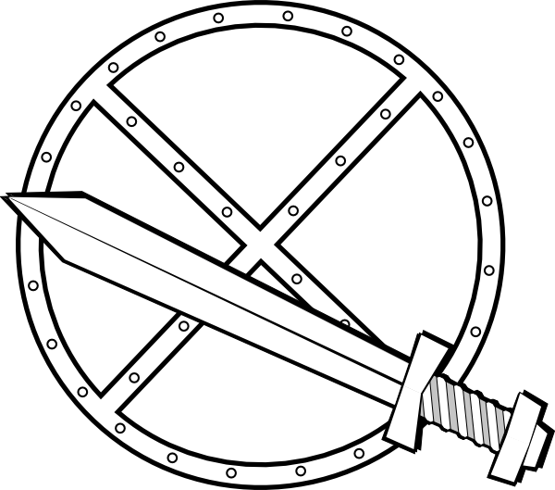
Viking Swords
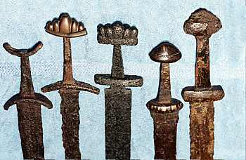
Viking swords were technologically ahead of their time compared to a lot of other metal weapons in Europe at the time. They were stronger and lighter than those of their opponents’, making Viking warriors more efficient in battle. We now know that the reason behind this actually had to do with their sword making rituals and superstitions. To have spiritual connections with their weapons in battle Vikings would burn bones of animals and ancestors to mix in with the iron during the smelting process of their weapons. The hope was that they would have the skills of their ancestors and the traits of the animal chosen. What they didn’t know was that by combining ancient iron with the carbon of burned bones, they were actually creating the equivalent of modern day steel. Steel being lighter, stronger, and more agile than the iron of surrounding areas. Magical runes would also be engraved into the handles and blades themselves as good luck charms. Handles were wrapped with different types of leather, fabric, or ribbons to allow the warriors the best grip possible.

Fun Fact! One quality sword in the Viking age was worth 16 milking cows! Today on average a milking cow is worth around $2000. Do the math!

Your Task: Draw and color your own Viking sword that is personal to you. Tell me what kind of animal you would mix with the metal of your sword and what skills you were hoping to get from it. You must also have some sort of runes on the handle or blade that has a significant meaning. It can be a descriptive word or a name or something else. You have a run sheet from the other day that tells you what each one means.

Viking Shields
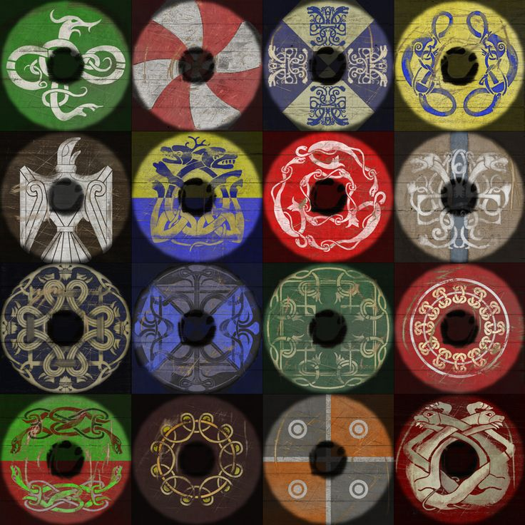
Historically speaking shields usually bear a coat of arms or a family symbol that represents the warrior or knight. Sometimes religious symbols were painted onto shields to show that they believed in their gods or god. The same is true with Vikings. Look at the examples below and create your own personal Viking shield based on the Viking style.

White: Purity, innocence, and birth
Yellow: purity, youth, happiness, hospitality
Orange: Strength, endurance, the eternal sun
Black: Eternity, darkest time before the dawn
Blue: The sky, air, good health
Green: Spring, new growth, and hope
Red: Happiness, hope, passion, the sun

