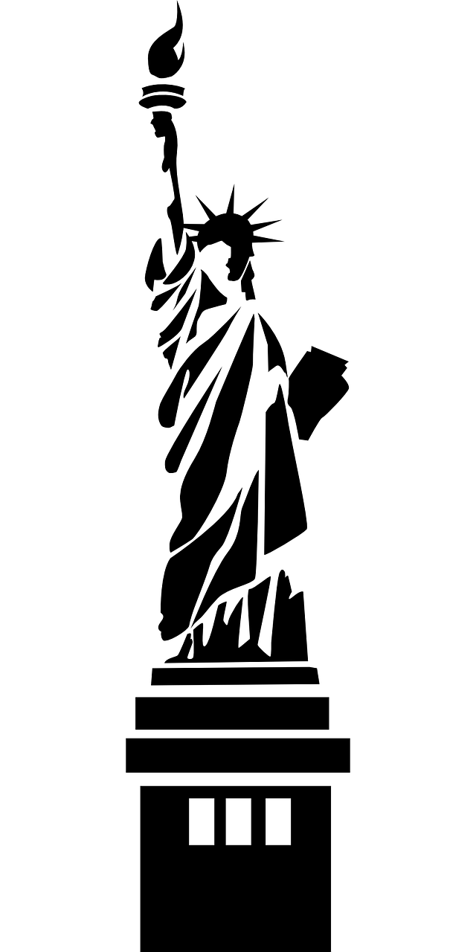
US History 2 Syllabus
Mrs. Doke’s Email: mdoke@eupschools.org Website: mrsdokes.weebly.com
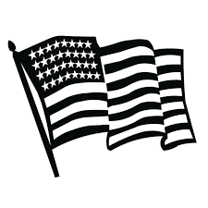
What We Will Learn

This class will cover the second half of American history. In your last us history class you should have learned about colonization up through the civil war. Starting with the 1840s era and up until current times you will be learning about the following subjects in this class (just to name a few):

- The gold Rush & Wild West
- Industrialization
- Immigration & Ellis Island
- World War 1
- The Roaring 20’s
- The Great Depression
- Prohibition
- World War 2
- The Cold War
- The Korean War
- The Civil Rights Movement
- The Space Race
- The Vietnam War
- Middle East Conflicts

Class Work & Homework
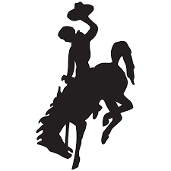
Instead of carrying around a heavy textbook we will be doing fill in the blank notes for this class. The only time you should have homework for this class is studying for a test, working on a long term project, or if you did not use your class time wisely. I expect your best work! I will try to mix it up between visual and written projects to give everyone equal opportunity when it comes to showing off what they are capable of.

Extra Credit
When it comes to history there are a lot of different ways to tell the story. If you want extra credit your job is to discover the truth. You need to compare a media interpretation of a historical event or person with the true events. You can use a movie, television show, video game, book, or something else! Just fill out the form and turn it into the inbox like any other assignment.
Another option for extra credit in history is writing a research paper on your own. If something interests you and you want to look more in depth into it, feel free to do so! Report back to me somehow (paper, movie, infographic, etc.) and you will get bonus points according to how awesome your work is.

Expectations
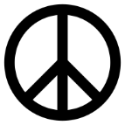
No matter which class I have you for (as I will have all of you twice a day) I have the same rules that need to be followed. And these rules apply even if I’m not here and there is a sub in my place:

- Be on time!
- Be prepared!
- Be respectful to EVERYONE!
- No drama!
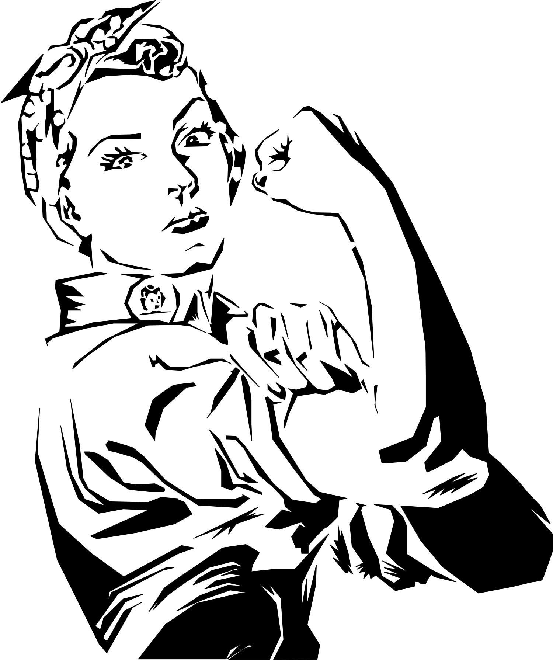
Other Policies

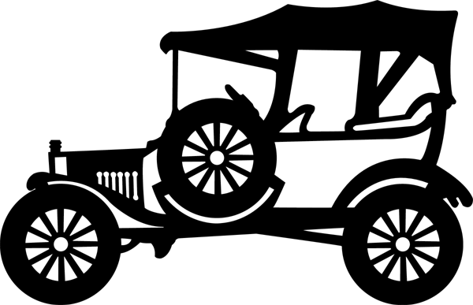
Cheating & Plagiarism
Just don’t do it. If I discover that you have used someone else’s work as your own on purpose you will get an automatic zero for that assignment, no matter how small it may be. If you have done so by accident (say, by using a quote and not citing it correctly) you will have one chance to redo the assignment.

Leaving the Classroom
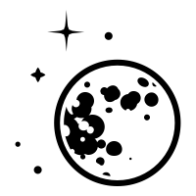
If you have to leave the classroom because you are not prepared, I will mark you as tardy. If you have to use the restroom, just tell me. If it becomes an every day thing I’m going to get suspicious and suspend these privileges! However if you are caught up on everything or currently have great grades you may be granted an honors pass when desired.

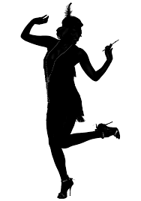
Listening to Music
When I give you class time to work on assignments you may listen to music on headphones if it helps you focus. This must be done through your laptop, no cell phones! I should not be able to hear it from across the room and it should not distract you or others from work. I can tell you to turn your music off at any time if I feel it is distracting… or just because I said so.

Free Time
If by some miracle you have completed all of your work for me to the highest expectations you have some options: 1. Extra credit. 2. Work that you have for another class. 3. Read a book. 4. Creative activities. No sleeping or distracting others!

Student Signature: ___________________________________________ Date: __________________

Parent Contact Info: ____________________________________________________________________

___________________________________________________________________________________________

