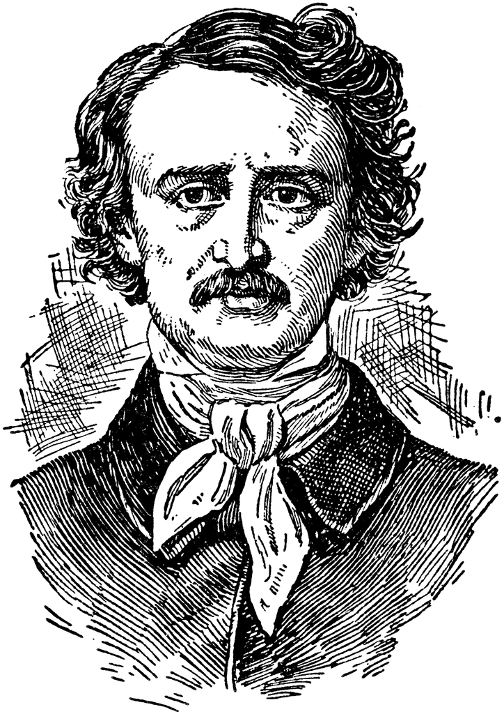
The Tell Tale Heart
By Edgar Allan Poe
Reading Worksheet

Part A – before you read
What are ten things that you would look for or expect in a scary story?

- __________________________________
- __________________________________
- __________________________________
- __________________________________
- __________________________________
- __________________________________
- __________________________________
- __________________________________
- __________________________________
- __________________________________

Part B – before and after you read
Read the following statements and decide whether you agree or disagree with them. After we have read the story, go back and decide if the author agrees or disagrees with the same statements.
Statement | You Agree | You Disagree | Author Agrees | Author Disagrees
People who are insane always know that they are insane.
Sane people sometimes imagine that they hear things.
If you commit a major crime, sooner or later you will be caught.
When you’ve done something wrong, it’s agony to wonder if you’ll get caught.
All people share the same fears (the same things frighten all people).

Part C – after you read
Review of the story. Answer the following questions and include evidence from the story to support you answers.
- Describe the narrator. What is your first impression of him?

- What specifically is it about the old man that troubles the narrator? Why does it trouble him?

- What does the narrator do every night? Why?

- How does the narrator feel after he commits murder? Is he worried about being caught?

- Why does the killer confess?

- Name three details, descriptions, or actions that the author uses to create an atmosphere of horror.

Part D – after you read
Fill out the Story Map/ Plot Line below with the elements of the story.
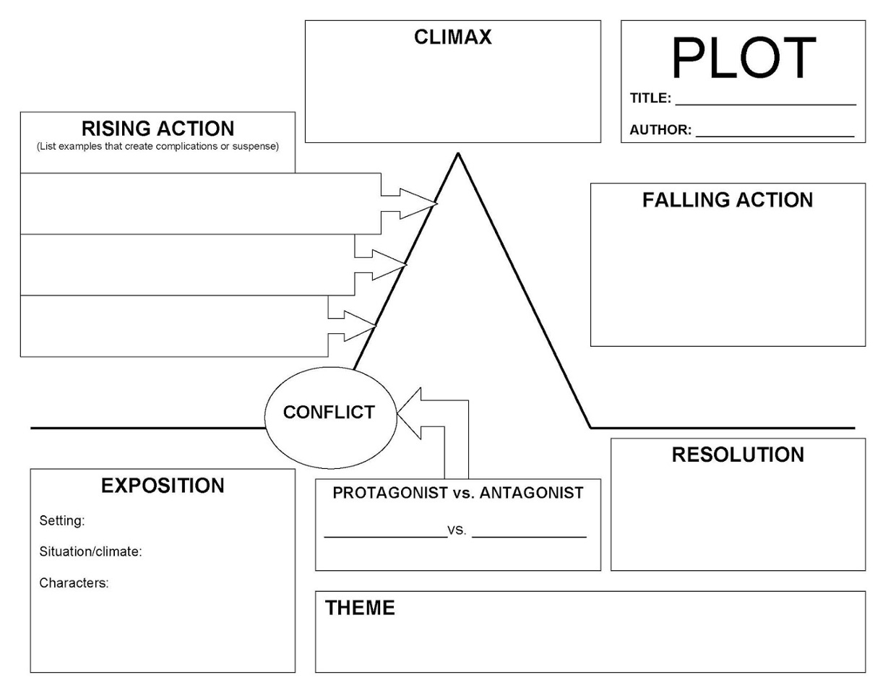
*If you need a reminder to any of the terms on this map (which I’m sure you all do) please look them up or we can discuss them as a class!

