The Raven by Edgar Allan Poe

Vocabulary Words: Define each of the words from “The Raven” below.

Aptly_______________________________________________________________________________________________________________________________________________________________________________________________
Beguiling____________________________________________________________________________________________________________________________________________________________________________________________
Bleak_______________________________________________________________________________________________________________________________________________________________________________________________
Censer______________________________________________________________________________________________________________________________________________________________________________________________
Dirges______________________________________________________________________________________________________________________________________________________________________________________________
Divining_____________________________________________________________________________________________________________________________________________________________________________________________
Entreating___________________________________________________________________________________________________________________________________________________________________________________________
Mien_______________________________________________________________________________________________________________________________________________________________________________________________
Pallas______________________________________________________________________________________________________________________________________________________________________________________________
Pallid_______________________________________________________________________________________________________________________________________________________________________________________________
Plume______________________________________________________________________________________________________________________________________________________________________________________________
Ponder______________________________________________________________________________________________________________________________________________________________________________________________
Rapping_____________________________________________________________________________________________________________________________________________________________________________________________
Ungainly____________________________________________________________________________________________________________________________________________________________________________________________
Wrought____________________________________________________________________________________________________________________________________________________________________________________________
Yore________________________________________________________________________________________________________________________________________________________________________________________________
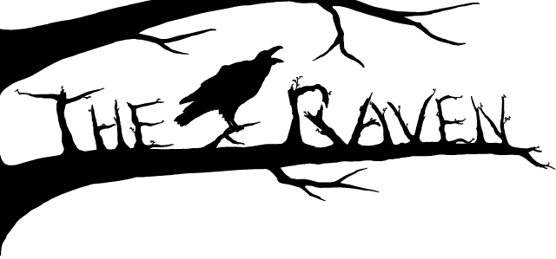

Literary Elements, PART 1: Give me a definition of each of the words below.

Alliteration__________________________________________________________________________________________________________________________________________________________________________________________
Assonance__________________________________________________________________________________________________________________________________________________________________________________________
Metaphor___________________________________________________________________________________________________________________________________________________________________________________________
Onomatopoeia_______________________________________________________________________________________________________________________________________________________________________________________
Personification_______________________________________________________________________________________________________________________________________________________________________________________
Simile______________________________________________________________________________________________________________________________________________________________________________________________

Literary Elements, PART 2: Give me an example of each literary element as it can be found in The Raven.
Alliteration:________________________________________________________________________________________
Assonance:________________________________________________________________________________________
Metaphor:_________________________________________________________________________________________
Onomatopoeia:____________________________________________________________________________________
Personification:____________________________________________________________________________________
Simile:____________________________________________________________________________________________

Reading Questions:
- What is the setting of this story?

- What is the name of the narrators lost love?

- What does the narrator see when he FIRST opens the chamber door?

- Where does the Raven perch when it flies in?

- What does the raven keep saying?

- The raven itself represents grief. What is the narrator grieving?

- What do you think “Nevermore” means in this poem?

