The Fertile Crescent
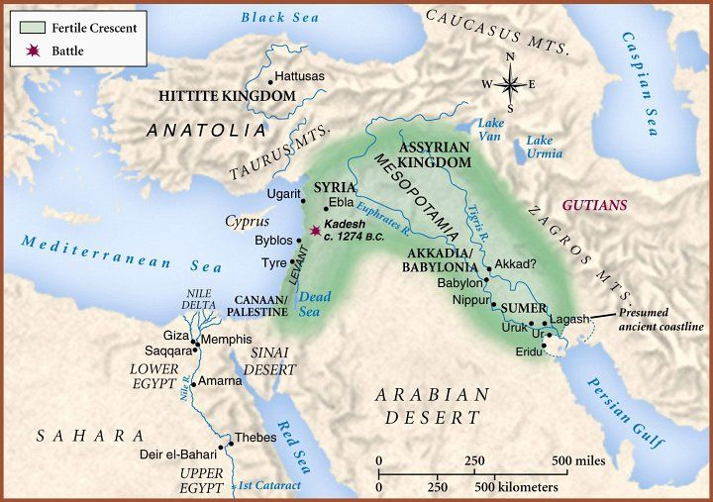
- Area between the __________________________________
________________________________________________________ grows in population and starts building a civilization during the same time period as the ________________________________________________.
- Includes parts of ___________________________________ Israel, Jordan, Lebanon, Turkey, Syria, and Iraq
- Mesopotamia means “________________________________________________________________” in Greek
- Unlike the Nile River, the _________________________________________ do not provide a regular water source – they ____________________________________________________ depending on the time of the year
  - _____________________________ swept away villages and fields
  - Water ________________________ vary from year to year
  - Eventually build _______________________________________________________________________ to control the water
  - Build _______________________________________________________________ to irrigate fields

The Sumerians
- Move to ______________________________________________________ around 3500 BC from Asia
- Call their city ________________________________
- By 3000 BC they have formed ________________________________________________
  - City ___________________________________________ ranging from 20K – 250K
  - Ur, Uruk, Eridu
- Ziggurat = ________________________________________________________
  - Made of _______________________________________________ and decorated with colored tile
  - Every city state had ________________
  - ___________________________________________________ that look like staircases
  - Shrine on _____________________
  - Only priests and priestesses are ________________________________________________________ the shrine
- City states rule themselves with ___________________________
  - _________________________________ leader
  - High ____________________________
  - Supervised ________________________________________
  - Enforces the _________________ and acts as _________________________ – __________________ instead of bodily injury or loss of life
- Created _________________________________________ writing
  - Oldest _____________________________ system in the world – 3100 BC
  - Wedge shaped markings put into wet __________________________________________________
  - Scribes keep all the ________________________________________
  - Oldest story in the world that is written down = ____________________________________
- Inventions
  - Wagon ___________________________________
  - Potter’s __________________________________
  - Arch
  - Sundial
  - Number system based on _____________
  - ____________ month calendar based on the cycles of the __________________________
  - Metal ________________________

Sargon I
- Born a ____________________________ to the Akkadian / Semite people
- Unites all the city states into one ___________________________________
- Overland __________________________________________________ between Egypt and Mesopotamia make people _____________________________________

Babylon
- King ________________________________________ creates a dynasty and brings this city to glory
  - Creates a ____________________________________________________
  - Civic work for ___________________________________ buildings and repair
  - Merchants from as far away as __________________________________________________ paid gold and silver for the _______________________________________________ made in Babylon
  - Hammurabi’s _____________________ is the first written down ___________________
    - ______________ sections dealing with every ______________________________________
    - Listed specific ___________________________________________ for each crime
    - Harsh _______________________________________ – “An eye for an eye and a tooth for a tooth.”
    - “If a builder has built a house for a man and has not made his work sound, so that the house he has made falls down and causes the death of the owner of the house, that builder shall be put to death. If it causes the death of the son of the owner of the house, they shall kill the son of that builder.”
    - Property of married women, adoption, inheritance, loans, damages made by cattle, protecting wives from abusive husbands, etc.
- Slaves are _________________________________________________________ or those that failed to pay their _____________________________
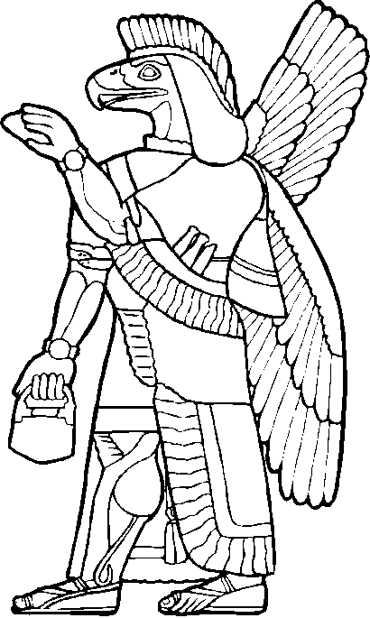
- Giant _____________________ structures that spanned over ______________________________________ of the Euphrates River
- Was the largest ___________________ in the world from 1770-1670 ____________
- World famous ___________________________ ________________________

