Roman Republic Notes

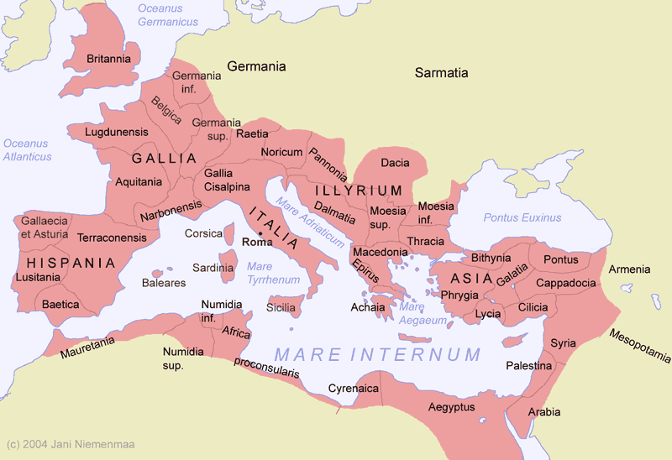
- Greeks colonize Italian Peninsula
  - Plant ______________________________________
  - Greek _______________________________
  - Middle of trade
  - ______________ to the North prevent invasion
- Etruscans
  - No one knows where they came from
  - We can’t understand their ____________________________, even though it is in the same alphabet
  - Beautiful ___________________________
  - Sacrificed _____________________________________________ or forced them to fight to the __________________________
  - Overthrown by the ___________________________

Rise of Rome
- ____________________________ and __________________________
  - Raised by a _______________________
  - Romulus __________________ Remus in a rage and uses his _______________________ in the mortar
  - City named after ___________________________
- ___________________ of Rome come together to form a large community
- Build with ___________________ and roof with __________________
- ________________________ square created
- The __________________ of the Sabine ______________________________
- Government
  - Eventually a _______________________________ is created
  - _______________ patrician officials elected for ________________________________ terms = executive branch = consuls
  - ____________________ – “I forbid”
  - Oversee _______________________, record keepers, and other public officials
  - _________________________________ appointed in time of crisis
  - Assembly of _______________________________ = ____________ elected officials
  - Senate = __________________ patrician men who serve for life
- Social Order
  - Patricians – ____________________________
    - Not _________________ to hold office
    - Make the ___________________
  - Plebeians – _______________________________ townspeople, landowners, merchants, shopkeepers, workers
    - Cannot hold _______________________________________________
    - Required to serve in _________________________________
    - Pay _________________________
    - Win the right to have their own ________________________________________ (tribunes)
    - Insist that the laws be written down for everyone to understand – ___________________________________________________

Religion
- Adopt Greek ___________________ but give them Roman _________________________
- Add _______________________, goddess of the hearth
- Oracles look through _____________________________________________________ to see the ___________________________________
- Ancestry ___________________________________

Family Life
- _________________________ is the absolute head of the _________________________________
- _________________________ tend to household duties and family shops
- Complete loyalty to ___________________________________________________
- ______________________________________ to all children to some point
- Roman _____________________________: thrift, discipline, self sacrifice, devotion

Roman Legion
- Every ____________________________________________ must serve
- ____________________________________ too large and slow
- Legion = _______________________ men
  - Smaller mobile units of ________________________________
  - Well trained
  - ________________________________ punished with _______________________
- Conquered people that serve in military given ____________________________________________________________________
- Coloniae – strategic _______________________________________________________
- Build _______________________________________________ to move goods and people

Rome against Carthage
- Carthage is the Mediterranean’s ________________________________________________
- Expanded outward to _______________________________________________
- Called “___________________________” by Romans
- 1st Punic War
  - _________________ BC
  - Carthage too close to Roman ___________________________________
  - Rome takes _________________________
  - Carthage ____________________ bigger Rome builds theirs up and goes on the attack with _______________________________________________
  - Carthage loses and pays ______________________________ – payment for damages
- 2nd Punic War
  - ________________ BC
  - ____________________________ becomes general of the Carthaginian army
  - Takes Roman city in ______________________
  - Marches ________________________ troops and 40 ________________________________ across the ____________ to take Rome – half _____________ in the crossing
  - __________________ attacks city of Carthage in Africa Hannibal runs home
  - Hannibal _____________________________ at Zama by Scipio ________________________________ land and warships and pay for indemnity
- 3rd Punic War
  - Carthage is ________________________________ and growing for ________ years
  - Rome just decides to _________________________________________ Carthage
  - __________________ Carthage, sell population into _____________________________, __________________ the Earth

Republic in Crisis
- Rome _________________________ Mediterranean to __________________________________
- Hard to ____________________________ far away areas from city of Rome
- Take tax _________________________________________________
- _____________________________________________ of tax collectors and governors
- Poor citizens ________________________________ of slave labor
- Rebellion = ________________________________________
  - Britannia – ____________________________________ (Hadrian’s Wall)
  - Palestine – _______________________________
  - Germanic tribes – ___________________________________

Reformers and Generals
- The Gracchi
  - __________________________________ of General Scipio
  - Tiberius Gracchus – _______________________________ by a _______________ for his ______________________________________ of giving to the poor (becomes a trend)
  - _____________________________ Gaius Gracchus elected later with the same beliefs – also killed by a _____________________
- General Gaius Marius
  - Poor ______________________________________________________ for jobs
  - __________________ soldiers
  - Get ______________________ at ____________________________________
  - _________________________ to their ________________________________________ instead of the __________________________________
  - His own ideas and army used _________________________________ him – General _______________________ takes over
- Triumvirate
  - General ____________________________, Marcus ______________________________, and ______________________________________________
  - ___________ BC
  - Caesar conquers the _______________________________________________
  - Crassus dies in __________________________ trying to prove that he is just as _________________________ as Caesar
  - Caesar told to leave his army at the __________________________________________ and to come home to Rome _____________________________ he just brings them _____________________________ takes over Rome and the empire (_______________________________________)
- Caesar
  - Makes himself __________________________________________________________
  - Starts _____________________________________________
  - Gives ___________________ to the unemployed
  - Public land to the _____________________
  - Citizenship granted to people that ____________________________________ the empire, not just those _________________ from Roman families
  - Adds ________________________________ representatives
  - Marries ___________________________________________ (even though he already has a __________________________________________)
  - Adopts Egyptian ____________________________________ and calls it the ________________________________ Calendar
  - ________________________________ March 15th, 44BC
    - “_______________________________________________________________________”
    - As he enters the Senate the senators pull out _________________________
    - Led by Marcus ______________________________ and Gaius Cassius
    - “E tu Brutus”
  - Ruled almost ____________________________

End of the Republic
- Octavian, Marc Antony, and Marcus Lepidus = _________________________________________
  - Divided Roman world up
  - Octavian takes ________________ and the West
  - Antony rules ___________________ and the East
  - Lepidus takes _________________________________________ (Egypt)
  - Octavian forces Lepidus to _________________________
  - Antony marries _______________________________________
  - Octavian declares _________________ on Antony
  - Octavian successful in war and almost __________________________________ Antony and Cleopatra = they commit _______________________________ in Egypt
- First emperors
  - Octavian changes his name to _______________________________________ – new _______________________________ of Rome
  - 27BC - 12AD
  - ___________________ imported from North Africa to feed everyone
  - New roads built and old ones __________________________
  - New ________________________________________________________ constructed throughout the empire
  - 31 BC = “________________________________________” that lasts about 200 years
  - Pax Romana = “_________________________________________________”
  - Good standard of living
  - The arts ______________________________________
  - _____________________________ pottery, woven cloth, blown glass, and jewelry
  - _________________________ for silk cloth, spices, tin, iron, and lead
  - Divorce and women’s rights
  - Public __________________________ are very popular
  - Government gives _________________________________________ and entertainment
    - Circus Maximus
    - Colosseum
    - ____________ holidays a year

Architecture and Engineering
- Pantheon
- Appian Way
- Aqueducts
- Columns and arches
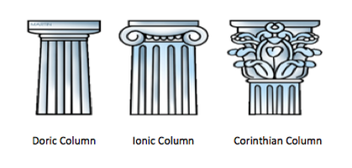
- Latin ____________________________ leads to Italian, French, Spanish, Portuguese, and Romanian

Julian Emperors – _________________________ to Julius Caesar in some way – “______________________________________________”
- Tiberius
  - Augustus’ adopted son
  - ___________________________ a lot of ______________________________________ people of ________________________________ against him
- Caligula
  - Born Gaius Caesar – gets his nickname from growing up in a military camp – “________________________________________________________”
  - Tiberius’ grand nephew
  - 5 brothers ____________________________ by Tiberius
  - Tiberius adopts him and teaches him about _________________________________
  - Mentally disturbed and _________________________________
  - Made his __________________________ a consul
  - _______________________________ by a palace guard
- Claudius
  - Caligula’s uncle
  - _______________________________
  - Gets a little _________________________ as he gets older
  - Poisoned by his ______________________
- Nero
  - Claudius’ stepson
  - __________________ and probably _________________________
  - _________________________________ treasury to pay for __________________________________________________ and music
  - __________________ his wife and mother – thinks they are plotting against him
  - Senate orders him to _____________________________________________ as execution

Good Emperors
- Nerva- Chosen by the ________________________________
- Trajan – expands empire to its ____________________________________________________
- Hadrian – many __________________________________________ projects
- Antonius Pius – no ______________________
- Marcus Aurelius – Philosopher that was good with _____________________________

Roman Rule
- About _____________________________________ people at its largest
- Emperors consider themselves ___________________
- Jus _____________________________ = laws for non citizens
- Jus _____________________________ = laws for citizens
  - State _____________________ the individual
  - Accused are _____________________________ until proven ____________________

Imperial Army
- Keep ____________________________________ soldiers
- Around ______________________________ troops to protect a ______________ mile border

Rise of Christianity
- Early Romans allowed to practice any religion ______________________________
- Christianity begins to emerge from _____________________________
- 6AD = _______________________ taken over by Rome
  - Romans ____________________ to Jews
  - Jews hope for the __________________________ to save them
  - ______________________________ back and forth
  - 132 AD – Jews kicked out of _______________________________________
- Jesus of Nazareth
  - _______________________________ turned ____________________________________
  - Practice kindness, repentance, and ____________________________________
  - Some Jews believed he was the son of __________________
  - Arrested by ____________________________________________________ for being a ___________________________________________________
  - ____________________________ until death – standard ____________________________ at the time
- Paul ____________________________ and spreads new religion after Jesus’ death
  - Writes _____________________________ to churches and temples
  - Writing forms some of the New Testament of ___________________
- _______________________________ begin spreading religion fast
- Peter sets up the first major Christian church in Rome = The __________________________
- Why some don’t like this new religion:
  - Only ______________ true god
  - Emperor not ____________________________
  - Refuse __________________________________ service (conscientious objectors)
- Accused of _______________________________ – put to _______________________
  - _______________________________ – people willing to __________________ for their beliefs instead of _________________________________ them
  - ___________________________________________ for sport

Constantine
- Has a vision of a _______________________________________________ in the sky
- Paints the cross on all of his army ______________________________ and they win
- ___________________________ to Christianity
- Becomes ________________________________ of Rome
- Theodosius – makes Christianity the official religion and _______________ all others
- Saint ___________________________________ writes about Christianity

Roman Decline
- ________________________________________ start invading
- 192-284 AD= army legions put ____________________________ emperors into power, only to kill them off when they are _______________________________________
- Warfare destroys ____________________ and the _________________________
- Start making money without the ____________________ to back it up
- __________________________________ and Constantine save the Empire
  - Make Constantinople the ________________________________________________
  - Try to make ____________________ to help the economy
  - Empire splits into ______________
    - ____________________ in the West
    - ________________________________________ in the East
- __________________________________ capture Rome
- _____________________________________________ raids Eastern Empire
- Rome falls in ____________________ = Odoacer, a Germanic chieftain, crowns himself _________________________________________
