Pride and Prejudice Netflix Series

Have you ever had a book that you’ve read turned into a movie or TV show? Netflix and other companies such as Hulu or Amazon Prime have gotten into the habit of making shows out of popular TV shows. These examples include: 13 Reasons Why, The Handmaid’s Tale, and Shadow Hunters. For this project you are going to summarize if Pride and Prejudice were turned into a television series. A lot happens in this story, so it makes for a good series option. You do NOT have to create a real series for this! You do NOT have to film anything. All you are doing is a synopsis/abstract for a “what if” this were a series. You are just creating a homepage.

You must have these parts:
- Part 1:
  - Cover Image & Title of Show (The font should be relative to the story itself like on other Netflix original shows)
  - Description of Show: Include/explain the main conflict(s) and the theme of the show. Write in present tense!
  - Rating (TV-14, etc.)
  - Genres
  - How many stars you gave it or a thumbs up or down
  - The standard buttons of Add to my list, more like this, etc.

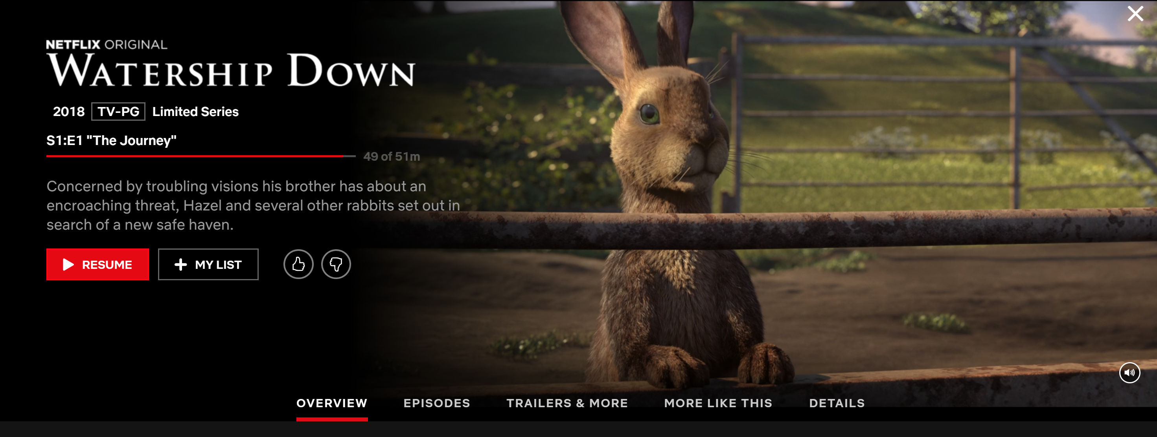

- Part 2: Episode Synopsis (5-10) episodes
  - Brief description/teaser of the episode.
  - Each episode should end on a cliff hanger or some enticement to come back and watch the next episode.
You may create this on your computer or by hand. Look at example Netflix screens for ideas. Even if you do not have a Netflix account you can look at menu examples on Google Images. You need to make your final product look as much like a real Netflix screen as possible!
Below are some examples from other students who have chosen to create a series by hand:
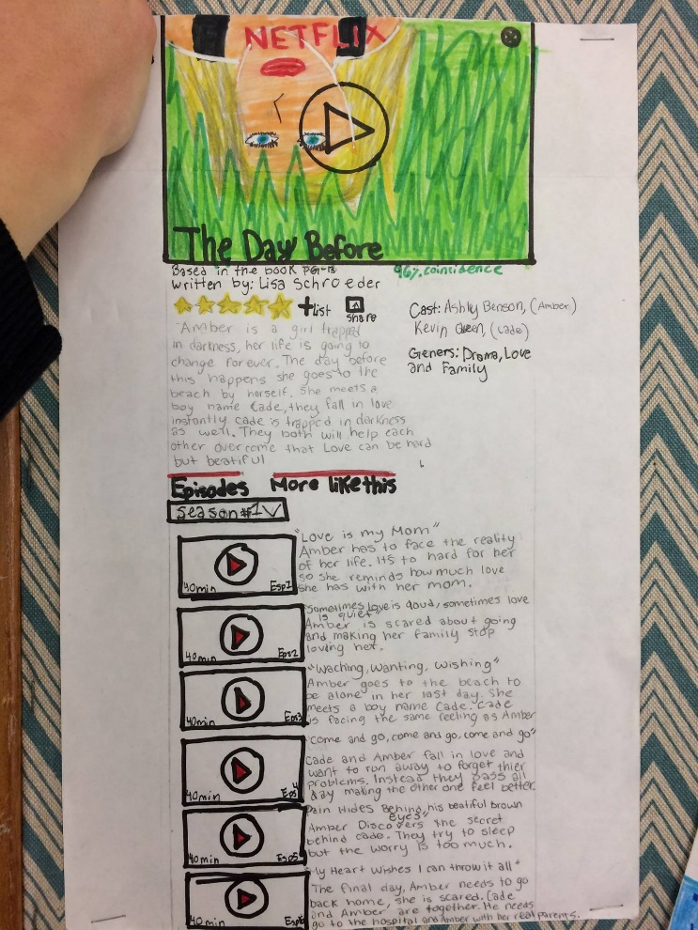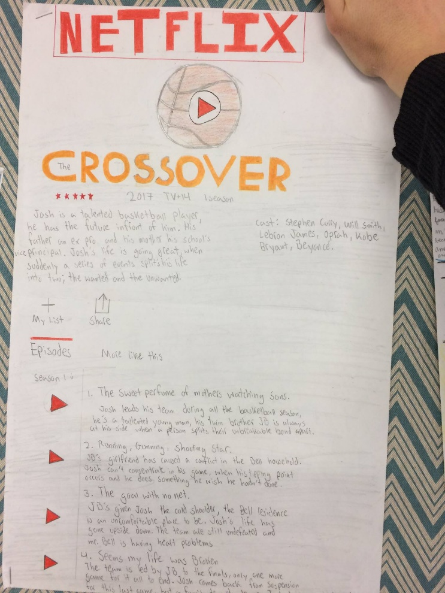

To help you I am including a timeline of the important events from Pride and Prejudice. Maybe go through the timeline and draw a line where you want each episode to begin/end.
Set in 19th century England, Pride and Prejudice traces the events in the lives of the Bennet’s over a period of a year, starting before Michaelmas of 1811 and ending before Christmas of 1812. The following is the chronology of the events in the story.
October 1811
- Bingley arrives in Netherfield
- Tuesday the 15th
  - Darcy insults Elizabeth at the Meryton Ball
  - Jane and Bingley attracted to each other
  - Militia regiment arrives at Meryton
November 1811
- Tuesday the 12th – Jane visits Netherfield and stays back because she falls ill
- Wed. 13th – Elizabeth goes to Netherfield to be with Jane
- Fri. 15th – Darcy begins to feel attracted to Elizabeth
- Mon. 18th – Collins arrives at Longbourn
- Tues. 19th – Jane, Elizabeth, Lydia, Collins, Bingley, and Darcy, and Wickham meet at Meryton
- Wed. 20th – Wickham tells lies about Darcy
- Tues. 26th – Elizabeth dances with Darcy at the Netherfield ball, her relatives expose themselves
- Wed. 27th – Collins proposes to Elizabeth, she refuses
- Sat. 30th – Charlotte and Collins are engaged to be married
December 1811
- Bingley leaves Netherfield
- Mon. 23rd – Gardiners visit Longbourn for Christmas
- Mon. 30th – Jane goes to London with the Gardiners
January 1812
- Thurs. 9th –
  - Collins and Charlotte marry and leave for Hunsford
  - Jane does not meet Bingley in London
March 1812
- Thurs. 5th –
  - Elizabeth visits Charlotte at Hunsford
  - Elizabeth dines at Rosings often this week
- Mon. 23rd – Darcy and Fitzwilliam arrive at Rosings
- Tues. 24th – Darcy visits the parsonage
April 1812
- Thurs. 9th –
  - Elizabeth learns from Fitzwilliam about Darcy’s interference in Bingley’s life
  - Darcy proposes to Elizabeth, she refuses
- Fri. 10th – Darcy gives Elizabeth a letter explaining his role in Bingley’s and Wickham’s affairs
- Sat. 11th –
  - Darcy leaves Rosings
  - Elizabeth goes to London
May 1812
- Elizabeth and Jane return to Longbourn
- The militia regiment leaves, Lydia goes with the Forsters
June 1812
- Elizabeth’s tour of the North with the Gardiners is postponed
July 1812
- Elizabeth visits Derbyshire with the Gardiners
August 1812
- Sat. 1st – Lydia elopes with Wickham
- Tues. 4th –
  - Mr. Bennet goes to London in search of Lydia
  - Elizabeth visits Pemberley, Darcy arrives
- Wed. 5th – Elizabeth meets Darcy, Georgiana, and the Bingleys for tea
- Fri. 7th – Jane’s letter about Lydia’s elopement arrives, Elizabeth leaves for Longbourn after informing Darcy
- Sat. 8th – Darcy leaves for London
- Sat. 15th –
  - Mr. Bennet returns to Longbourn
  - Darcy calls on Mr. Gardiner in London
- Mon. 17th – Mr. Gardiner writes to Mr. Bennet that Lydia and Wickham are to be married
- Mon. 31st –
  - Lydian and Wickham are married
  - Lydia and Wickham visit Longbourn
September 1812
- Fri. 4th – Elizabeth writes to Mrs. Gardiner asking her for an explanation after Lydia discloses that Darcy attended her wedding
- Sun. 6th – Mrs. Gardiner replies
- Thurs. 10th – The Wickham’s leave
- Thurs. 17th – Bingley returns to Netherfield
- Sat. 19th – Bingley and Darcy call on the Bennets
- Wed. 23rd – Darcy confesses to Bingley about his interference with Jane
- Sat. 26th – Bingley proposes to Jane, they are engaged
October 1812
- Sat. 3rd – Lady Catherine visits Longbourn
- Sun. 4th – Collins writes to Mr. Bennet about the rumor of Elizabeth’s engagement to Darcy
- Tues. 6th – Darcy proposes to Elizabeth
Jane and Bingley marry, Elizabeth and Darcy marry

