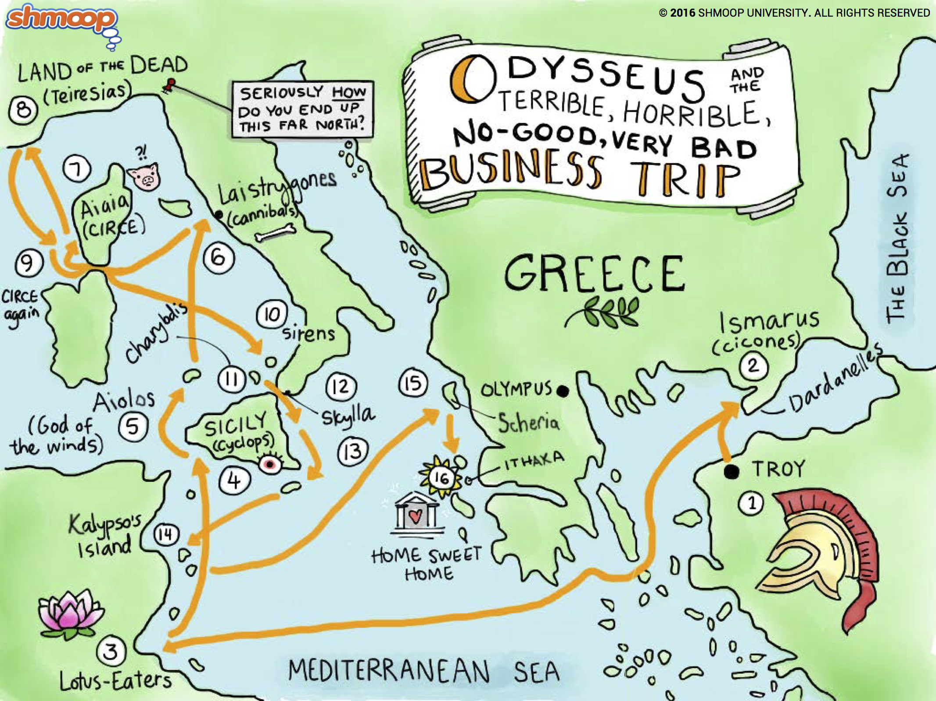

The Odyssey Timeline and Map

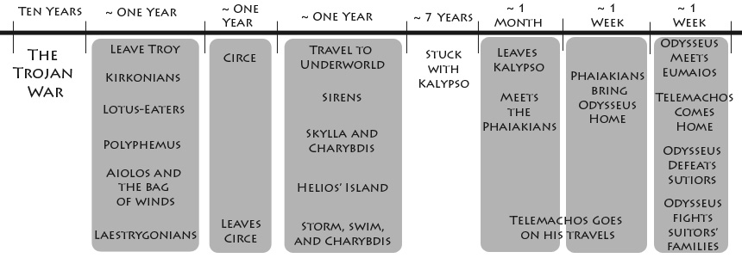

**The Odyssey**

**Book 5**

**The Odyssey**

**Books 1-4, 6-8**

**The Odyssey**

**Books 9 - 12**

**The Iliad**

**The Odyssey**

**Books 13-24**