Create A Location & Identification Guide

Now that you have gone through all of the European Mythological Creatures that we are going to cover, your task is to make a location guide for people on where they can find each creature. You will include a map for each creature that shows the areas of Europe that you can originally find these things (I will upload a picture of a map of Europe that you may download and use). You will include a picture of one of these creatures so that people know what they are looking for. You may make this digital or draw it out. You can print off pictures from the computer and then color them and attach them to other paper. It’s up to you! The pictures need to be in color! You may work with a partner on this project. Below you will find an example of a location guide page:

Figure 1: Be sure to add a picture of your creature next to the map so that people can easily identify which creature you are talking about.

Figure 2: Maybe your creature originated in one area but has spread to other areas in modern times.

Figure 3: Another example of various areas for a creature to be. Can also be different colors for different kinds of the same creature (such as dragons, werewolves, vampires, etc.). Be sure to put the title of the creature somewhere on your page too, so that people know what it is called.

Figure 4: Different breeds of the same creature can be showcased if there are different kinds. Different angles may give your audience a better understanding of what to look for. Anatomy charts are great for pictures as well!

So what are need on every page are:
- Cover for your Guide Book
- Title of creature
- A colored map of Europe that shows where they are found
- A color picture or pictures of the creature to easily identify the creature
- All creatures from the notes (29 of them)
- Table of contents or index (which means that you have to have page numbers!)
- Bonus Points! Put the scientific name for each creature under the title (Yes, they do exist)!

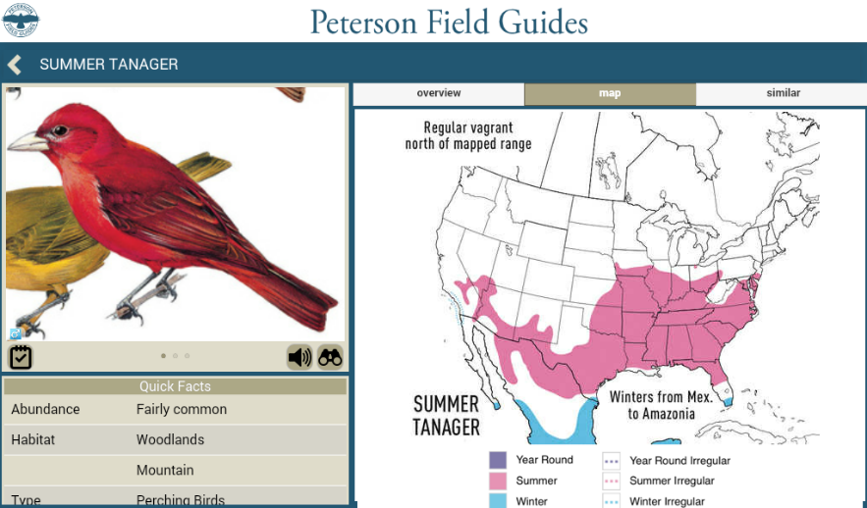
Figure 1
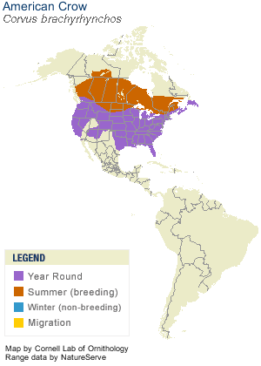
Figure 2
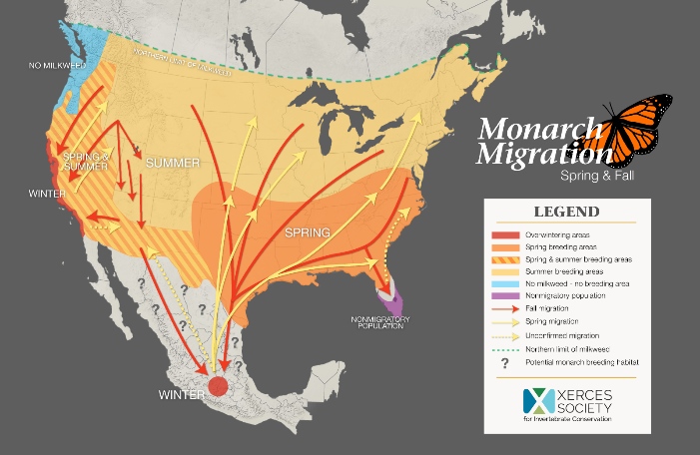
Figure 3

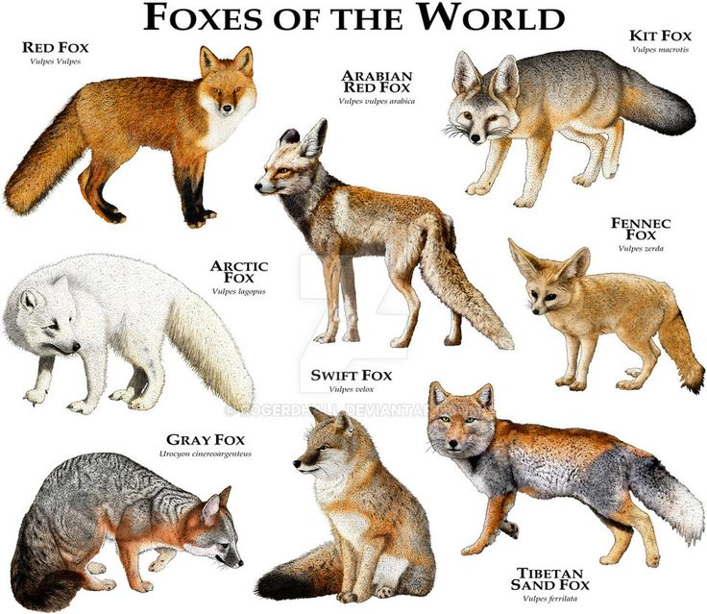
Figure 4

