Famous Author Trading Cards
50 Points Total

For this assignment, you must choose five famous authors and create a type of collectible trading card that represents each author. Use the website https://bighugelabs.com/deck.php to generate your trading cards. For each card you must have:

- You will need a picture of the author. You will have to find a picture online and save it to your computer in order to upload it to the website.
- You will need 5-7 relevant facts about each author. It should be enough to fill the text section of the card.
- Include their full name and what genre they are best known for, if there is more than one genre then list them.
- Choose a style of background for the card that you think fits and at least one icon that goes along with the author. For example, if they write a lot of romance books choose a heart. If they write about animals, choose the horse icon.
- Be sure to copy and paste your sources into a separate word document to include in your final email.

Once you have fully created each card be sure to save it as a picture somewhere that you can easily access it later. Below is a list of authors that would be a good pick for this project. If you do not see the author of your favorite book on the list below feel free to check with me if you can still do them! The authors listed below are just some of the most popular authors. You must do different authors than your classmates!

- Agatha Christie
- Bram Stoker
- Charles Dickens
- Clive Cussler
- CS Lewis
- Dr. Seuss
- Edgar Allen Poe
- Ernest Hemingway
- F. Scott Fitzgerald
- George Orwell
- George RR Martin
- Harper Lee
- HG Wells
- James Patterson
- Jane Austen
- JK Rowling
- John Green
- John Steinbeck
- JRR Tolkien
- Jules Verne
- L. Frank Baum
- Lewis Carroll
- Lois Lowry
- Maggie Stiefvater
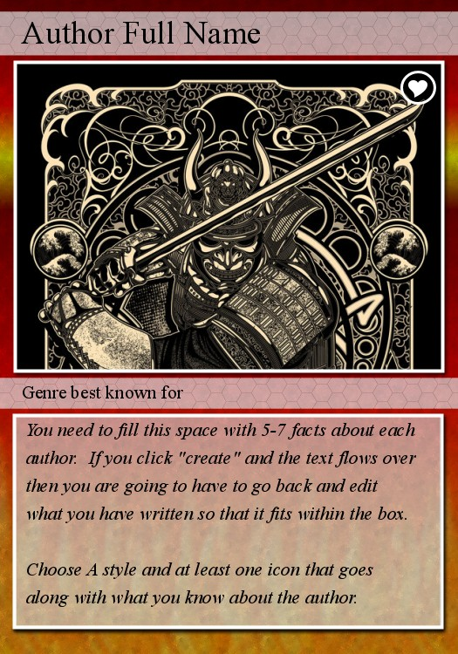
- Mark Twain
- Mary Shelley
- Maya Angelou
- Michael Crichton
- Neil Gaiman
- Oscar Wilde
- Peter S Beagle
- Ray Bradbury
- Rick Riordan
- RL Stine
- Roald Dahl
- Robert Louis Stevenson
- SE Hinton
- Sir Arthur Conan Doyle
- Stephen King
- Tom Clancy
- William Dashner
- William Goldman
- William Shakespeare

