Ancient Civilizations Architecture - Informational Flyers

Create a one page flyer informing people about one of the following:

- Acropolis
- Alexandria
- Athens
- Babylon
- Corinth
- Great Temple of the Aten
- Karnak
- Library of Alexandria
- Luxor
- Memphis
- Mortuary Temple of Hatshepsut
- Olympia
- Panathenaic Stadium
- Parthenon
- Pyramid of Djoser
- Sparta
- Temple of Delphi
- Temple of Dendur
- Temple of Edfu
- Temple of Hephaestus
- Temple of Ramses II
- The Great Ziggurat of Ur
- Theater and Temple of Apollo
- Thebes
- Theater of Dionysus

On your flyer you must include:
- A picture of the outside
- A picture of the inside
- Title – The name of the building in large letters at the top
- Where was it located in ancient times?
- Where is it in modern times?
- Size – how tall is it or how long or how many city blocks, things like that
- What was the original purpose of the building?
- Who built it? Either what ruler or what cultural group of people
- How was it built? Any special technology? A ton of manpower?
- What is it made out of?
- Why is the building no longer in use? Earthquake, religions changed, etc.
- Any fun facts that are relevant or what makes the building special

You may use word, publisher, or a different program of your choosing. But it must be done on the computer, not by hand.

On the back of this paper you will find an example that I have made.

The Great Pyramid of Giza
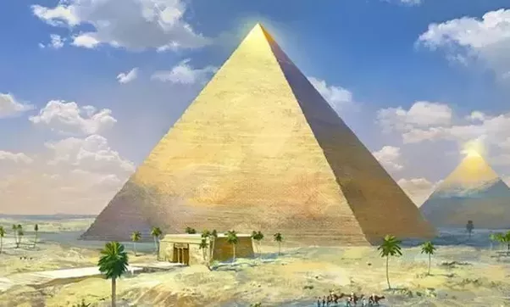
Ancient World Location: Egypt’s Lower Kingdom

Current World Location: Cairo, Egypt

Built in: 2560 BC

Original Size: 481 feet tall, 756 feet wide on all sides

Original use: Burial Tomb for Pharaoh Kufu

Built by: Pharaoh Kufu using slave/ hard labor workers

Built using: Unknown technology

Made out of: Limestone

No longer in use because the tomb and building have been sacked by grave robbers and for building materials

Fun facts:
- Oldest of the seven wonders of the world, and only survivor
- Largest pyramid in Egypt
- Built using 2.3 million stone blocks
- No writing inside
- Three burial chambers have been found inside
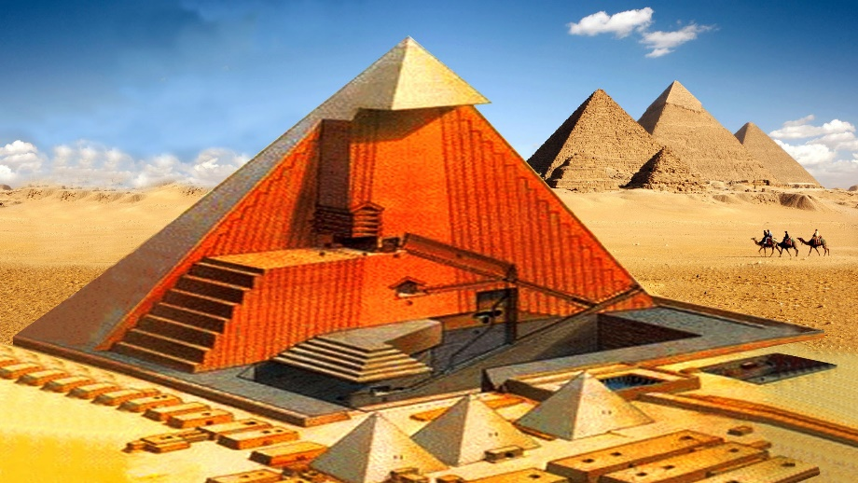
- We cannot build an exact replica of the pyramid even using todays modern technology
- It took over 20 years to build, and even then each block had to have been placed every 2.5 minutes

