1970s Game Show Research

With the invention of the television in 1927 came a lot of questions about what broadcast companies should air in order to keep viewers glued to their sets. The first Game Show was called “Truth or Consequence”, which aired in 1941. It was an experimental show that offered contestants the opportunity to get trivia questions right, or have to do wacky stunts instead. The final prize was money that the person could take home with them for completing the trivia and trials.

During the late 60s and early 70s the golden age of game shows came about. Some of these are still on television today, and some were so crazy that they have been left in the past. Your task for this assignment is to research one of the popular game shows from the 1970s. The list below gives some great examples, but if you find a different one on your own, feel free to choose that one. Once you have picked your game show of choice, answer the questions.

- Celebrity Sweepstakes
- Family Feud
- Hollywood Squares
- Jeopardy
- Let’s Make A Deal
- Match Game
- Name That Tune
- Now You See It
- Password
- Supermarket Sweep
- The $10,000 Pyramid
- The Dating Game
- The Gong Show
- The Newlywed Game
- The Price is Right
- To Tell the Truth
- Wheel of Fortune

- How do you play the game?___________________________________________
________________________________________________________________________________________________________________________________________________________________________________________________________________________________________________________________________________________________________
- When did it air?_______________________________________________________
- What channel did it air on?___________________________________________
- Who was the host? (If more than one, list both the original host and one that was during the 70s)____________________________________
__________________________________________________________________________
- What was the prize at the end?_____________________________________
- What happened if you lost?___________________________________________
__________________________________________________________________________
- Find a picture of the original set and logo, email them to me or print them off and staple to this sheet.
- Watch an episode of the show (or clips if a full episode is not available). They are available on YouTube.
  - Give an example of a question that is asked.__________________
__________________________________________________________________________________________________________________________________________
  - What do you think of the show, now that you watched it?
__________________________________________________________________________________________________________________________________________
  - Do you think that you would be able to win this game? Why or why not? ______________________________________________________
_____________________________________________________________________
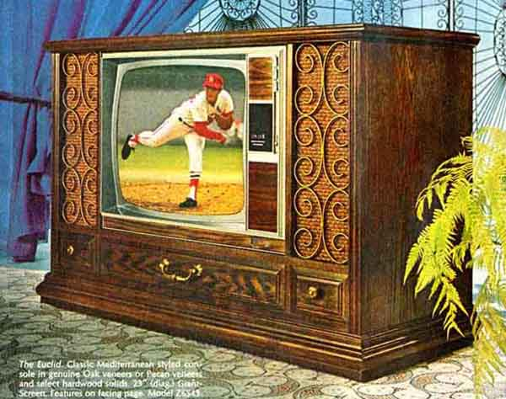
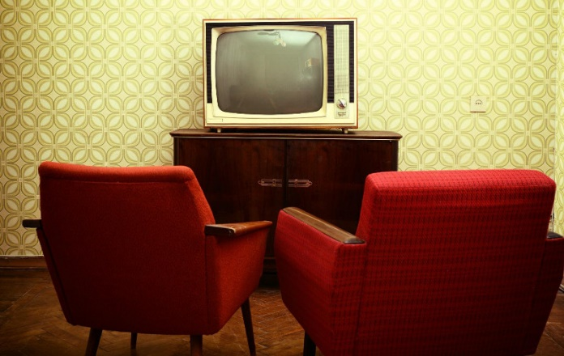
To the left you will see a classic TV set up of the 1970s. No remote. No flat screen. Largest size available was 24 inches (if you were super rich).

